Virtual Payments from WebBeds
WebBeds has made a commitment to pay suppliers with electronic virtual card numbers (VCCs) from WEX, Citi and HSBC—this will reduce manual payment processes and ensure suppliers are paid in a faster and more secure manner

Introducing VCCs from WEX, Citi and HSBC

Single-use electronic card numbers with transactional data attached
Secure and controlled payment method
Globally accepted by suppliers via existing point-of-sale (POS) terminals

Benefits to the business

Easy to use with no development required: Process VCCs via your existing POS system as a card-not-present transaction

Saves time and frees up account’s resources: A unique card number per transaction and the ability to customise data recorded can help you automate reconciliation work

Payments received faster: Automated payment processes facilitate faster receipt of payment, which can help improve cash flow
Risk of fraud reduced: VCCs are single-use, and controls can be used to avoid fraudulent use

Guarantees payment: As VCCs facilitate faster payment, you do not need to worry about late or non-payments

Reduces the cost of receiving payment from overseas: You will receive payment via a VCC in your local currency, which avoids fees for accepting payment in a different currency

Frequently Asked Questions

How to know if VCC was charged or declined by using DOTWConnect? How to know the reason of decline?
If a card is charged successfully or not, it will be shown in the transaction logs & real time authorisations & decline table.

Transaction Type: D = Charged C= Refund.

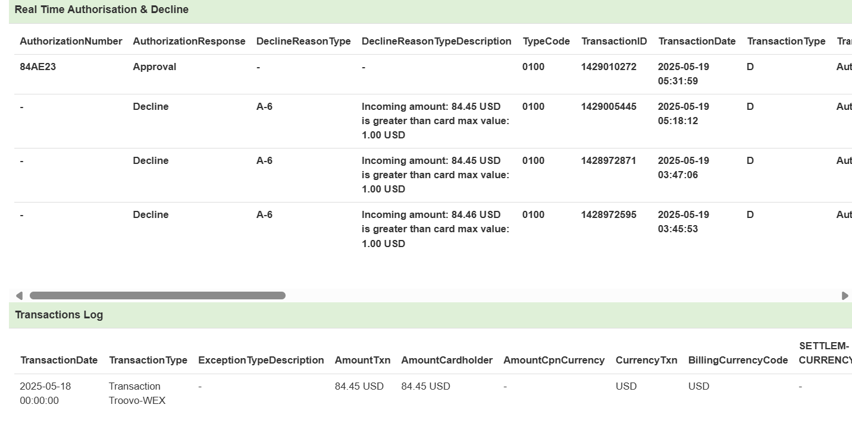

How to have DOTWConnect Access?
This should be provided upon onboarding, if not available then request via Service Desk.

What can you see in the DOTWConnect as a Customer Service Agent?
Everything relevant to the booking and card history, status, transaction logs is available to CS team.
Only difference is the card details, CVC and expiration date are masked.

Is there a time limit on when a VCC can be charged?
Yes, the validity of our cards for Flexi-rate bookings is usually from check-in date up to check-out + 30 days.
There are suppliers who have different schedule of card loading date, but they also have until check-out + 30 days to charge our cards.
For Non-Refundable bookings, the validity is from the booking creation up to check-out + 30 days.

What to do if I want to request a VCC to be deleted?
vCarly users should be able to have the DELETE Access in DOTWConnect.
If no access yet to delete, inform VCC team and we can request on your behalf.

Steps how to close:
In finance tab, Choose Virtual CreditCards then select Close VCC.

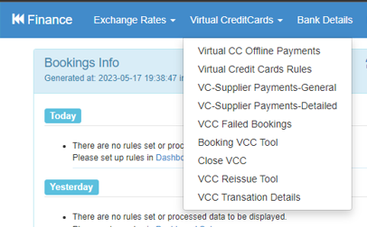

Enter the booking you want to close, and the reason then click Close Card.

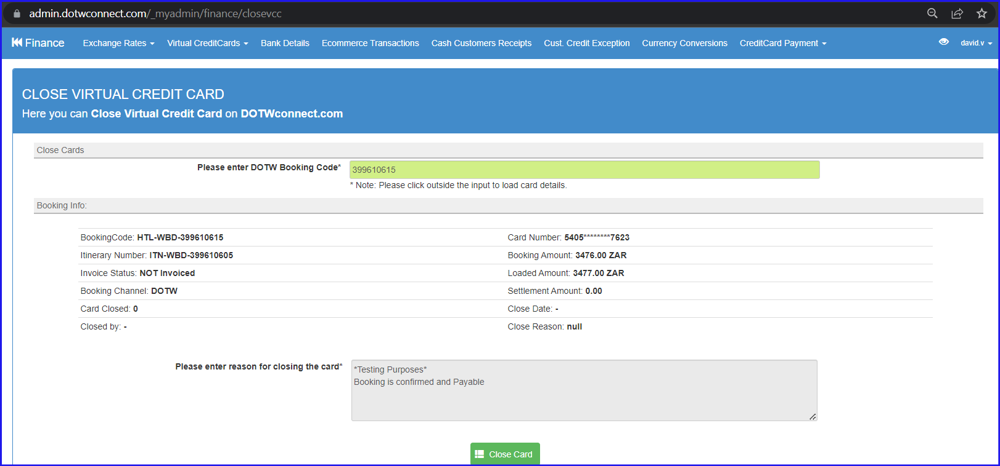

Wait for the confirmation that card has been closed successfully.

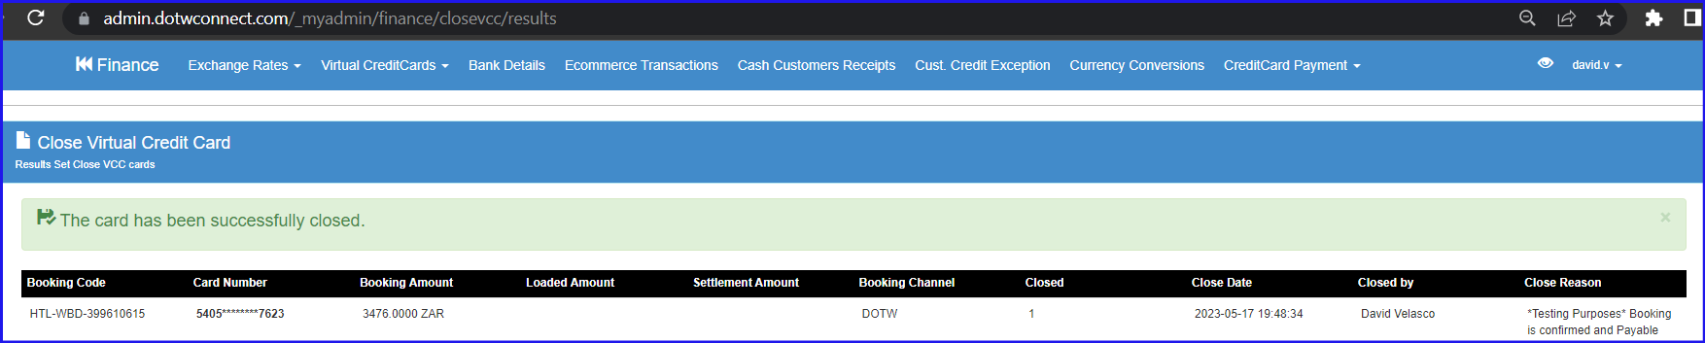

Does VCC needs to be updated when the booking is amended?

Booking Price Change (OBA) | If VCC is Open (Active) | If VCC is Closed (Inactive)
Price Increases | Same card is reloaded with extra amount | - New VCC is created for the extra amount
Price Decreases | Same card load is reduced to new price | - No new VCC
Price Drops to Zero | Card is cancelled/marked as deleted | - No action
Multiple Price Changes | Same card is adjusted up/down each time | - New VCC created for Delta with each change

How to know if a booking is supported by VCC?
Check profile of Hotel and Payments Tab should show that VCC is enabled.

What to do when vCarly is not working?
Take a screenshot of error and report to VCC team or Rendani Netshaulu.

Who are the escalation points?
Christelle Canlas, David Velasco, Francis Xavier Bueno and Bashia Pobre.

